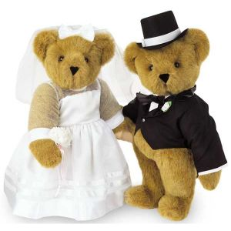

Aja Lightsey
Neden
English 9
27 March 2012
I chose this image because I think it represents Act II scene IV well. This is because in Act II scene IV Romeo tells the nurse that he wants Juliet to meet him at the church so that they may get married. In this image there are two bears in a wedding suit and gown. One would assume they are going to get married because of their apparel, and in this particular scene Romeo and Juliet want to get married. Although they only met a few hours ago, they feel as if they are already in love, so they want to prove their love for each other. In the previous scene romeo went to Friar Laurence to ask if he would assist him in the marriage, at first the Friar was very surprised, but in the end he agreed to assist Romeo. The two of them barely know each other and they want to promise their love to each other, which I think is ridiculous.

